Abiotic vs. Biotic
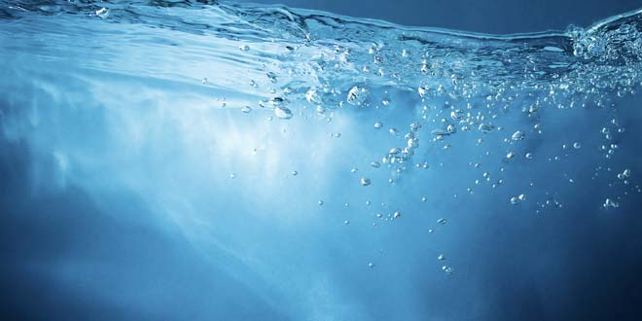
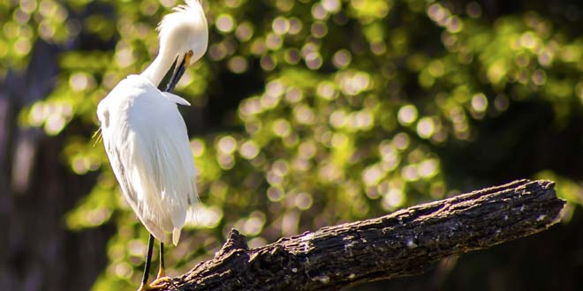
Diffen › Science
Abiotic factors refer to non-living physical and chemical elements in the ecosystem. Abiotic resources are usually obtained from the lithosphere, atmosphere, and hydrosphere. Examples of abiotic factors are water, air, soil, sunlight, and minerals.
Biotic factors are living or once-living organisms in the ecosystem. These are obtained from the biosphere and are capable of reproduction. Examples of biotic factors are animals, birds, plants, fungi, and other similar organisms.

Comparison chart
Differences — Similarities —
Abiotic versus Biotic comparison chart
 | Abiotic | Biotic
Introduction | In ecology and biology, abiotic components are non-living chemical and physical factors in the environment which affect ecosystems. | Biotic describes a living component of an ecosystem; for example organisms, such as plants and animals.
Examples | Water, light, wind, soil, humidity, minerals, gases. | All living things — autotrophs and heterotrophs — plants, animals, fungi, bacteria.
Factors | Affect the ability of organisms to survive, reproduce; help determine types and numbers of organisms able to exist in environment; limiting factors restrict growth. | Living things that directly or indirectly affect organisms in environment; organisms, interactions, waste; parasitism, disease, predation.
Affects | Individual of a species, population, community, ecosystem, biome, biosphere. | Individual of a species, population, community, ecosystem, biome, biosphere.

